**END TERM EXAM(JAVA)**

**NAME : PANKAJ BHATT**

**STUDENT ID :20711041**

**MCA HLD**

1. **Write an applet program which can perform the arithmetic operations like Sum, Subtract, Multiplication & Division.**

**Ans:**

import java.awt.*;

import java.awt.event.*;

class calculator implements ActionListener

{

//Declaring Objects

Frame f=new Frame();

Label l1=new Label("1st Number");

Label l2=new Label("2nd Number");

Label l3=new Label("Operation Result");

TextField t1=new TextField();

TextField t2=new TextField();

TextField t3=new TextField();

Button b1=new Button("Add");

Button b2=new Button("Sub");

Button b3=new Button("Mul");

Button b4=new Button("Div");

Button b5=new Button("Cancel");

calculator()

{

//Giving Coordinates

l1.setBounds(50,100,100,20);

l2.setBounds(50,140,100,20);

l3.setBounds(50,180,100,20);

t1.setBounds(200,100,100,20);

t2.setBounds(200,140,100,20);

t3.setBounds(200,180,100,20);

b1.setBounds(50,250,50,20);

b2.setBounds(110,250,50,20);

b3.setBounds(170,250,50,20);

b4.setBounds(230,250,50,20);

b5.setBounds(290,250,50,20);

//Adding components to the frame

f.add(l1);

f.add(l2);

f.add(l3);

f.add(t1);

f.add(t2);

f.add(t3);

f.add(b1);

f.add(b2);

f.add(b3);

f.add(b4);

f.add(b5);

b1.addActionListener(this);

b2.addActionListener(this);

b3.addActionListener(this);

b4.addActionListener(this);

b5.addActionListener(this);

f.setLayout(null);

f.setVisible(true);

f.setSize(400,350);

}

public void actionPerformed(ActionEvent e) {

int n1=Integer.parseInt(t1.getText()); int n2=Integer.parseInt(t2.getText()); if(e.getSource()==b1)

{

t3.setText(String.valueOf(n1+n2)); }

if(e.getSource()==b2)

{

t3.setText(String.valueOf(n1-n2)); }

if(e.getSource()==b3)

{

t3.setText(String.valueOf(n1*n2)); }

if(e.getSource()==b4)

{

t3.setText(String.valueOf(n1/n2)); }

if(e.getSource()==b5)

{

System.exit(0);

}

}

public static void main(String...s)

{

new calculator();

}

}

**Output:**

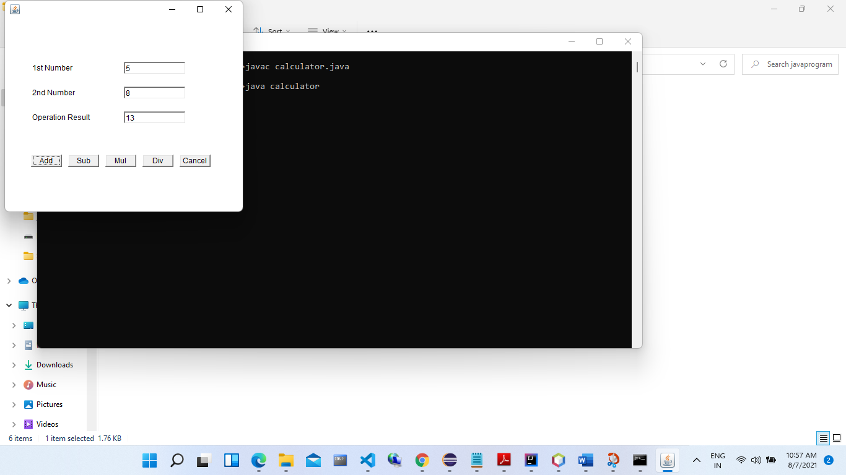

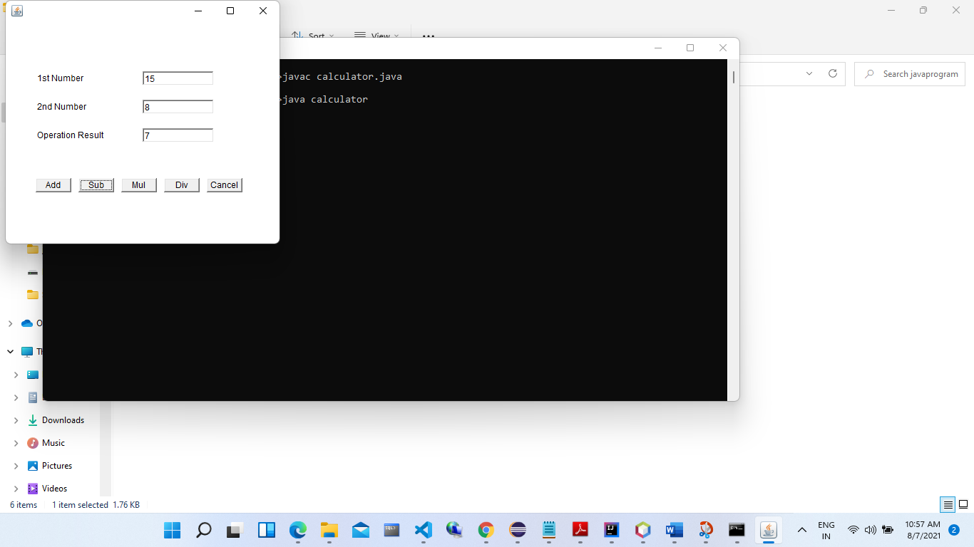

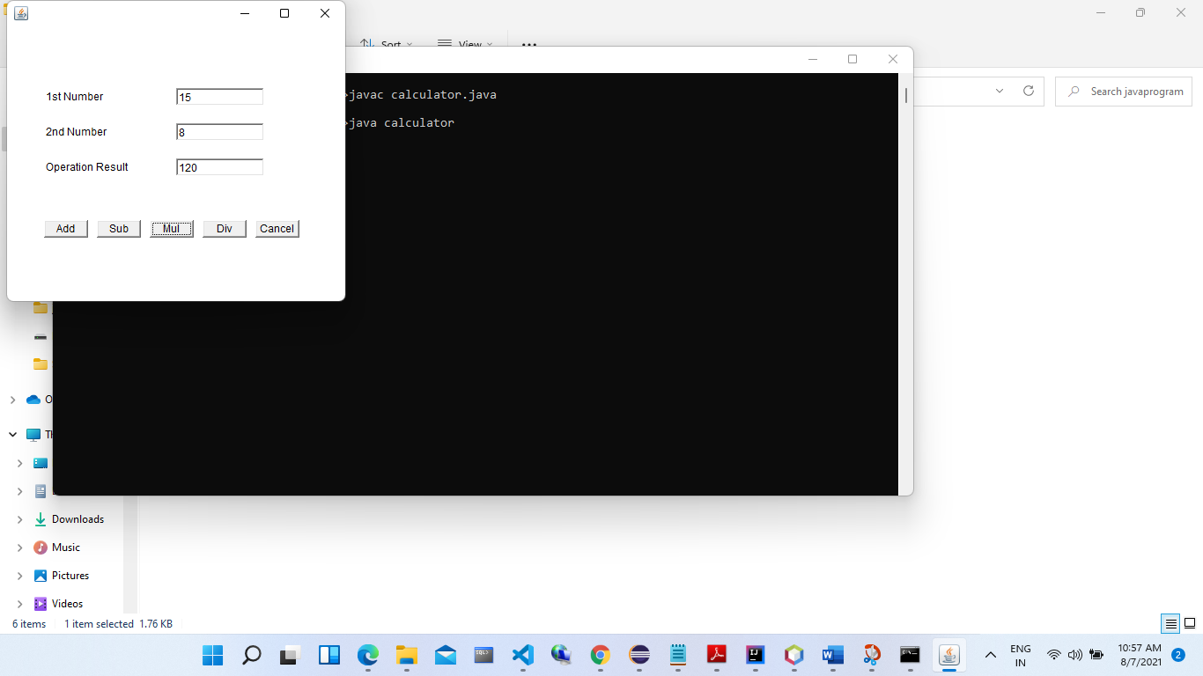

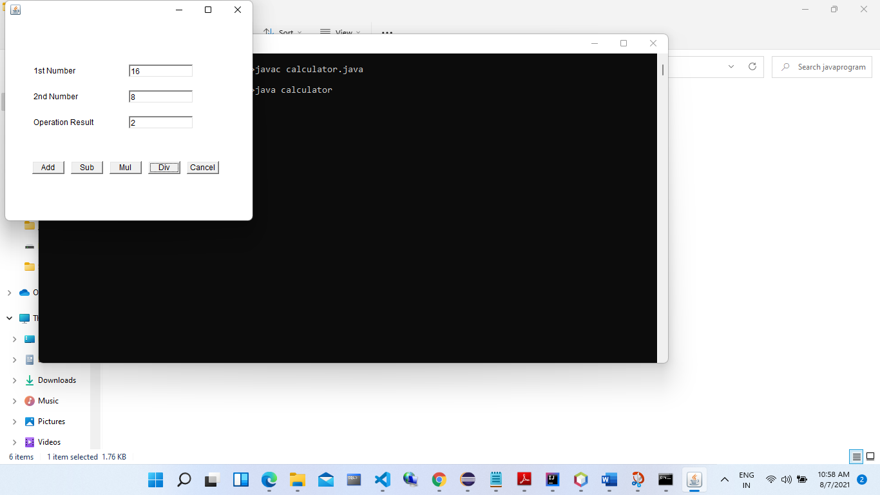

Answer 2;I

import java.io.BufferedReader;

import java.io.FileReader;

public class Pankaj

{

public static void main(String[] args) throws Exception {

String line;

int count = 0;

FileReader file = new FileReader("pankaj.txt");

BufferedReader br = new BufferedReader(file);

while((line = br.readLine()) != null) {

String words[] = line.split(" ");

count = count + words.length;

}

System.out.println("Number of words present in given file: " + count);

br.close();

}

}

**Text File:**

**Test**

**pass**

**fail**

**nest**